**SMART PARKING**

**Phase 2 Submission Document**

**Team members**

S. Swetha- (732721121055)  
 M. Sindhu - (732721121046)  
 T. Srimathi- (732721121051)  
 C. Chanthruba- (732721121007) R. Bharathi- (732721121006)

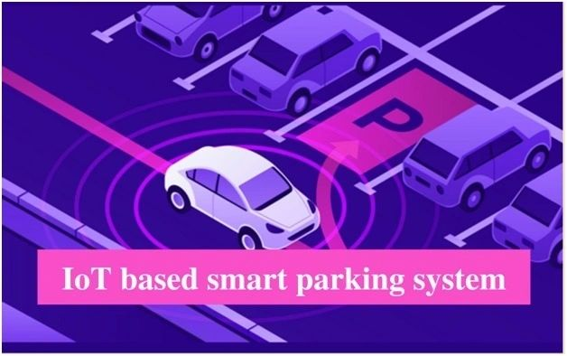

**Introduction:**

The goal of parking system project is to reserve parking spot for a car/vehicle before it arrives. One of the most problems that the driver faces is finding a free parking spot, so many driver stopping their cars at the edges of the street. Therefore, we choose this to prevent the frustration of finding a parking spot and they can reserve a spot when they stay at home. It is an IOT based project.**Problem statement:**

One of the most problems that the driver faces is finding a free parking spot. It encompasses various challenges, such as congestion in urban areas, inefficient use of parking spaces, and the need for a seamless and convenient parking solution. In urban and suburban areas, the existing traditional parking systems are plagued by inefficiency, congestion, and a lack of user convenience. It leads to traffic, environmental impact, wastage of stress and time, economic losses, high fuel consumption,etc..

**Innovation:**

To overcome the above given statement we proposed an IOT based application for Smart parking systems, users may access information about available parking spaces, reserve spots and make payments through a custom IOT application provided by the parking facility or the parking services. We choose this to prevent the frustration of finding a parking spot and they can reserve a spot when they stay at home. Sensor-based technology is used to monitor parking spaces in real-time. Drivers can access information through mobile apps or electronic signage to find available parking spots, reducing the time spent searching for a space.

**Requirements:**

* 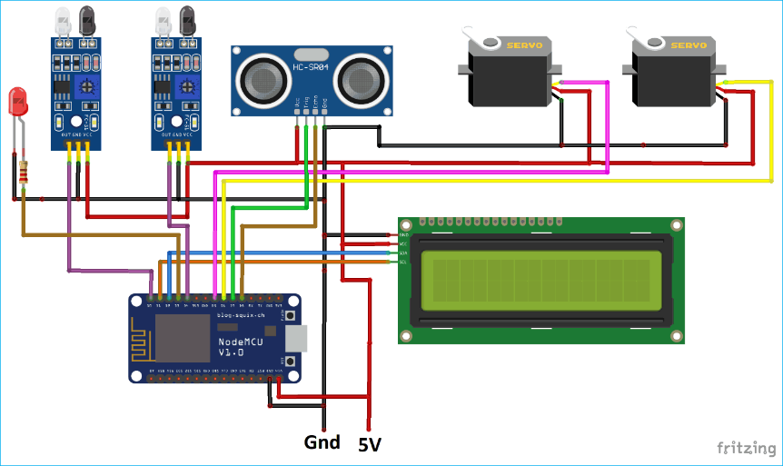Arduino MEGA
* Ultrasonic sensor
* IR Sensors
* LCD(Liquid Crystal Display)
* Jumpers
* RFID Reader(Radio frequency identification)
* Servo motor
* ESP8266 Serial Wi-Fi module
* Red, Green, Blue LED’s
* Telnet application

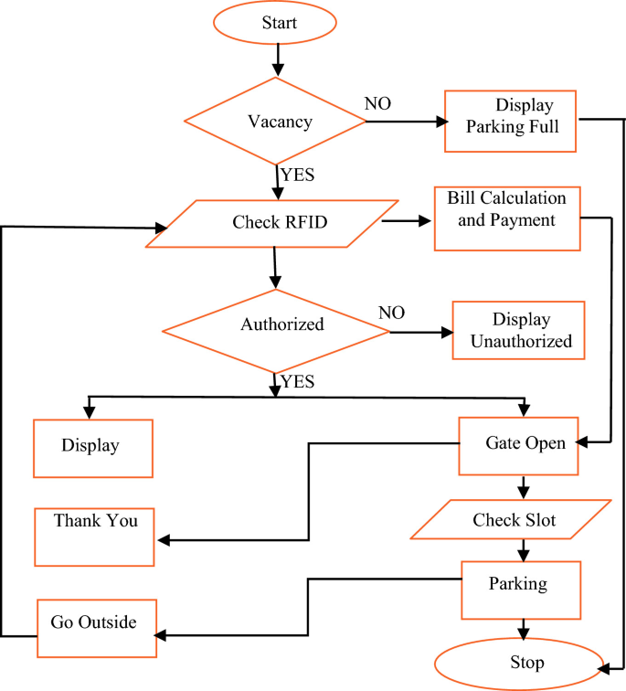**Flowchart:**

**Program:**

#include <Ultrasonic.h>

#define NUM_PARKING_SPACES 4

Ultrasonic ultrasonic[NUM_PARKING_SPACES] = {

Ultrasonic(2, 3), // Trigger, Echo for Space 1

Ultrasonic(4, 5), // Trigger, Echo for Space 2

Ultrasonic(6, 7), // Trigger, Echo for Space 3

Ultrasonic(8, 9) // Trigger, Echo for Space 4

};

int parkingSpaceStatus[NUM_PARKING_SPACES] = {0}; // 0 = vacant, 1 = occupied

void setup() {

Serial.begin(9600);

for (int i = 0; i < NUM_PARKING_SPACES; i++) {

pinMode(i * 2 + 2, OUTPUT); // Initialize LED pins for each parking space

}

}

void loop() {

for (int i = 0; i < NUM_PARKING_SPACES; i++) {

long distance = ultrasonic[i].timing();

int status = parkingSpaceStatus[i];

// Adjust the threshold based on your sensor placement and environment

int threshold = 20; // Distance threshold (in cm) to detect a car

if (distance < threshold && status == 0) {

// Vehicle detected

parkingSpaceStatus[i] = 1;

digitalWrite(i * 2 + 2, HIGH); // Turn on LED for occupied space

Serial.print("Space ");

Serial.print(i + 1);

Serial.println(" is occupied.");

} else if (distance >= threshold && status == 1) {

// Space vacated

parkingSpaceStatus[i] = 0;

digitalWrite(i * 2 + 2, LOW); // Turn off LED for vacant space

Serial.print("Space ");

Serial.print(i + 1);

Serial.println(" is vacant.");

}

}

}

**Conclusion:**

Smart parking solutions offer a comprehensive approach to tackling the challenges associated with parking in today's urban environments. While initial implementation can be an investment, the long-term benefits in terms of reduced traffic congestion, environmental impact, and improved user experiences make smart parking a valuable addition to modern cities. As technology continues to advance, smart parking systems are likely to evolve and become even more integral to urban planning and sustainability efforts.

**Future work:**

The future of the smart parking system is expected to be significantly influenced by the arrival of automated vehicles (Avs). Several cities around the world are already beginning to trial self-parking vehicles, specialized AV parking lots and robotic parking valets.